**Emotion Annotation Instructions**

*Task Description and Annotation Guidelines.* You are invited to take part in the annotation study of developers' contributed texts in Free Open Source Software (FOSS) communication platforms; such as pull requests, issue comments, and chat messages. We are interested in annotating the presence of emotions in online developer interactions.

The data sources are GitHub forums of four open-source projects: flutter/flutter (https://github.com/flutter/flutter), webpack/webpack (https://github.com/webpack/webpack), microsoft/TypeScript (https://github.com/microsoft/TypeScript), and angular/angular (https://github.com/angular/angular). You will be required to annotate 1200 randomly selected developer communications, each often containing multiple sentences. The unit of annotation is either an entire issue comment, pull request comment, or a single chat utterance. You should be considering the emotions of the entire unit and not of each sentence belonging to a data point.

You will use the coding schema reported in TABLE A. **For each row in the spreadsheet, please indicate what emotion it conveys (if any) among the basic emotions (first column in the table), which are:** *Anger, Love, Fear, Joy, Sadness, Surprise.*   
Multiple Emotion labels from (*Anger, Love, Fear, Joy, Sadness, Surprise*) are allowed but you should try to avoid them if possible.

You can use the second and third levels in the schema as a reference for choosing the primary emotion, but the annotation should be only for the primary emotions. You should provide the second and third-level emotions whenever they are prevalent. You should provide a rationale for each selection.

Note that, each basic emotion also exists in second or third level emotion. So whenever you choose just basic emotion, make sure to choose the respective second or third level emotion. For example, if an instance is labeled *love*, you should select second-level emotion as *affection*, and third-level emotion as *love*.

Table A:

| **Basic Emotion: Definition** | **2nd level emotion** | **3rd level emotion** | **Examples** |
| --- | --- | --- | --- |
| Love: A strong positive emotion of regard and affection (expressing gratitude) | Affection | Liking, Caring, Compassion, Fondness, Affection, Love, Attraction, Tenderness, Sentimentality, Adoration | 1. Thanks for your input! You’re, like, awesome.  2. Thanks very much! I appreciate your efforts  3. I would love to try out a patch for [... ] |
| Lust | Desire, Passion, Infatuation, Arousal |
| Longing |  |
| Joy: A feeling of pleasure and happiness. | Cheerfulness | Happiness, Amusement, Satisfaction, Bliss, Gaiety, Glee, Jolliness, Joviality, Joy, Delight, Enjoyment, Gladness, Jubilation, Elation, Ecstasy, Euphoria | 1. I’m happy with the approach and the code looks good  2. great work you guys!  3. Hope this will help in identifying more use cases |
| Zest | Enthusiasm, Excitement, Thrill, Zeal, Exhilaration |
| Contentment | Pleasure |
| Optimism | Hope, Eagerness |
| Pride | Triumph |
| Relief |  |
| Approval |  |
| Admiration |  |
| Enthrallment | Rapture |
| Anger: A strong feeling of displeasure or antagonism | Irritation | Annoyance, Agitation, Grumpiness, Aggravation, Grouchiness | 1. I will come over to your work and slap you  2. WTF, a package refactoring and class renaming in a patch?  3. This is an - ugly - workaround  4. I find the idea of “local” types declared within the implementation body to leak outside extremely unpleasant and disturbing. |
| Exasperation | Frustration |
| Rage | Anger, Fury, Hate, Dislike, Resentment, Outrage, Wrath, Hostility, Bitterness, Ferocity, Loathing, Scorn, Spite, Vengefulness |
| Disgust | Revulsion, Revulsion, Loathing |
| Envy | Jealousy |
| Disapproval |  |
| Torment | --- |
| Sadness: Emotional pain, sorrow. | Suffering | Hurt, Anguish, Agony | 1. Sorry for the delay Stephen.  2. Sorry of course printStackTrace() wont work  3. wish i had pay more attention in my english class .... now its pay back time .... :-(  4. Apache Harmony is no longer releasing. No need to fix this, as sad as it is. |
| Sadness | Depression, Sorrow, Despair, Gloom, Hopelessness, Glumness, Unhappiness, Grief, Woe, Misery, Melancholy |
| Disappointment | Displeasure, Dismay |
| Shame | Guilt, Regret, Remorse |
| Neglect | Embarrassment, Insecurity, Insult, Rejection, Alienation, Isolation, Loneliness, Homesickness, Defeat, Dejection, Humiliation |
| Sympathy | Pity |
| Fear: Being afraid or worried. | Horror | Alarm, Fright, Panic, Terror, Fear, Hysteria, Shock, Mortification | 1. I'm worried about some subtle differences between char and Character  2. I'm most concerned with some of the timeouts  3. I suspect that remove won’t work either in this case. |
| Nervousness | Anxiety, Distress, Worry, Uneasiness, Tenseness, Apprehension, Dread |
| Surprise: Feeling astonished, startled by something unexpected. | Surprise, Realization, Confusion, Curiosity | Amazement, Astonishment | 1. I still question the default, which can lead to surprisingly huge memory use  2. I also documented an unexpected feature with the SlingServletResolver  3. Oops. It needs to be added to Makefile |
| Politeness | Gratitude: E.g., I really appreciate that you’ve done them.  Deference: E.g., Nice work so far on your rewrite.   Greeting: E.g., Hey, I just tried to . . .  Please: E.g., Could you please…? | Positive lexicon  E.g., Wow! This is a great way to deal.  Apologizing  E.g., Sorry to bother you. | 1. Polite: “Do you have any code that we can look at?”  2. Impolite: “Any code? Or do I have to guess at how you did it?” |

Reference paper: [Emotion knowledge: Further exploration of a prototype approach](https://scholar.google.com/scholar?hl=en&as_sdt=0%2C47&q=Emotion+knowledge%3A+Further+exploration+of+a+prototype+approach.&btnG=) by Shaver et al.

Examples are from: [An exploratory qualitative and quantitative analysis of emotions in issue report comments of open source systems | SpringerLink](https://link.springer.com/article/10.1007/s10664-017-9526-0) by Murgia et al.

Definitions from GoEmotions by Demszky et al.: <https://arxiv.org/pdf/2005.00547.pdf>

**Admiration:** Finding something impressive or worthy of respect.

**Amusement:** Finding something funny or being entertained.

**Anger:** A strong feeling of displeasure or antagonism.

**Annoyance:** Mild anger, irritation.

**Approval:** Having or expressing a favorable opinion.

**Caring:** Displaying kindness and concern for others.

**Confusion:** Lack of understanding, uncertainty.

**Curiosity:** A strong desire to know or learn something.

**Desire:** A strong feeling of wanting something or wishing for something to happen.

**Disappointment:** Sadness or displeasure caused by the nonfulfillment of one’s hopes or expectations. **Disapproval:** Having or expressing an unfavorable opinion.

**Disgust:** Revulsion or strong disapproval aroused by something unpleasant or offensive. **Embarrassment:** Self-consciousness, shame, or awkwardness.

**Excitement:** Feeling of great enthusiasm and eagerness.

**Fear:** Being afraid or worried.

**Gratitude:** A feeling of thankfulness and appreciation.

**Grief:** Intense sorrow, especially caused by someone’s death.

**Joy:** A feeling of pleasure and happiness.

**Love:** A strong positive emotion of regard and affection.

**Nervousness:** Apprehension, worry, anxiety.

**Optimism:** Hopefulness and confidence about the future or the success of something.

**Pride:** Pleasure or satisfaction due to ones own achievements or the achievements of those with whom one is closely associated.

**Realization:** Becoming aware of something.

**Relief:** Reassurance and relaxation following release from anxiety or distress.

**Remorse:** Regret or guilty feeling.

**Sadness:** Emotional pain, sorrow.

**Surprise:** Feeling astonished, startled by something unexpected.

Mappings by GoEmotion:

| Joy | Approval, Admiration |
| --- | --- |
| Anger | Disapproval |
| Surprise | Realization, Confusion, Curiosity |

Top 5 keywords associated with each emotions by GoEmotions:

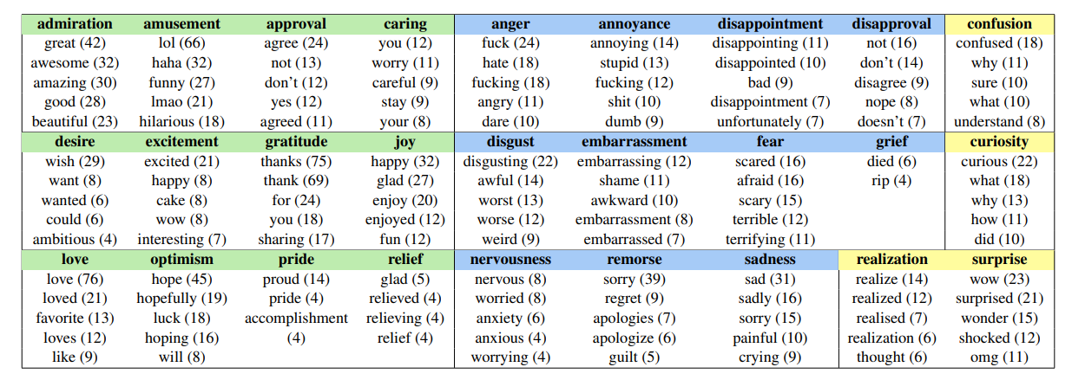



* “Helpful” can be used to show caring/compassion (Love). It can also be considered as “joy” if someone is trying to help (Enthusiasm -> Joy).

* Wishing something -> Longing

* Expressing gratitude (Appreciation, Gratitude, Compliment) -> Love (by definition).

* Showing concern about something -> Worry -> Nervousness -> Fear

* Sometimes Uncertainty may express Curiosity (due to lack of information), or Confusiton (due to lack of understanding).